Social Science 3A
Yingxuan Ma
March 21, 2023

Social Media Effects on Stock Trading

Introduction

As investments become increasingly prominent in the finance world, it is essential to consider their impact on players outside of big financial companies that control significant assets. Today's investment situation is no longer as complicated due to the existence of social media platforms such as Reddit and the emergence of the application Robinhood. Robinhood is an American stockbroker that provides commission-free stock and ETF trading. According to Bloomberg, more than 40% of Robinhood's income in 2018 comes from the contentious Wall Street practice of selling its users' orders to high-frequency trading companies or "market makers." (Bloomberg).
On social media sites like Reddit, thousands of regular investors compete against wealthy professional Wall Street traders. And just recently, the underdog has triumphed. Shares of GameStop have increased by more than 6500% (Bloomberg). The stock increased 400 percent just in the previous week. However, as analysts are unable to identify a fundamental cause for the stock's growth, the surge cannot be attributed to GameStop's business strategy. It will be finally attributed to the extraordinary trading strategy redditors in Wallstreetbets come up with: short squeeze.
This project uses online forum discussions from Reddit to better understand how people talk about their stock trading experiences as retail investors. Specifically, this study examines the culture of Wallstreetbets, their social interaction with each other in the subreddit, and finally, the trading strategy that is most frequently mentioned. A diversified small group accurately represents a larger population. Representative samples are good for more objective and various inputs. The population would be retail investors who trade in the US stock market. Investors online are oriented around social support and in-depth stock strategy discussions. While they participate in sharing strategies for making money, there are also patterns in socialization and trading strategy reflected on the social media platform Reddit.

Literature Review

The literature review explores the existing research on the impact of different medias and strategies on stock market. In the article Market Declines: What Is Accomplished by Banning Short-Selling? It is related to the concept that big institutions place short selling positions on stocks without prosperous growth in the future and making money out of it. The “Hedgy” coalition make them better off by collecting many small pieces of profits from retail traders. That’s why their actions are resentful for retail investors. It is evident that banning the short selling strategy can necessary. Kurani et al. (2023) found that two important algorithms that play a big part in stock forecasting Artificial Neural Networks (ANN) are able to function even when certain data points are absent. Support Vector Machines (SVM) provides a number of advantages and prevents over-fitting. The authors discovered that SVM and ANN are two of the most practical methods that may be applied to boost stock prediction accuracy. To improve accuracy, ANN can be further integrated with other technologies like data analysis and other programs. Another study also investigates the effects of artificial intelligence on stock index prices. ANN are very good at discovering precise answers in environments with complicated, unpredictable, irrelevant, or incomplete input (Wen et al.. 2019) Pan, Zhuang, and Fong (2016) found that different data normalization techniques on the ability of support vector machines (SVM) and technical indicators to forecast changes in stock index price. Employing complimentary methods and mathematics proof to evaluate the processing time, the authors are able to clearly conclude a negative correlation between the number of feature adopted to train a model and the prediction system based on SVM model. Their results indicate that due to the complexity of the stock movement, single-algorithm prediction algorithms frequently is not enough to give accurate result and forecast. So retail investors could take the advantage to thrive using social media platforms.

Method

The subreddit that I chose to explore is in the investment category, which is named Wallstreetbets. The subreddit Link is https://www.reddit.com/r/wallstreetbets/. This subreddit is for participants (investors) to discuss stock and option trading. It was built originally to serve as a small forum for high-risk investors. There are in total 15 data pieces that I analyze 5 posts with 3 comments each. This amount is adequate to be a representative sample for observing the socialization online and their investment hobbies, and their points if view on short squeeze in particular. There is about 13.6 million members subscribed to this subreddit category, at the time I visit there is 24.9k online active users. My objective is to explain how people interact on the website and to comprehend this subreddit culture. I've spent more than five weeks in investigating and joining the discussion as a redditor in the forum.

Finding and Analysis

  - Culture of Wallstreetbets
The culture in this forum is humorous and sarcastic. People often make jokes about the market and are sarcastic about their situation or the stock options they bought. It is a culture filled with humor, companionship, and rivalries, all of which are undercut by an underlying resentment of hedge funds that view them as naive traders who can be fooled and defrauded of their money. The forum's language can be difficult to understand for the general crowd. The vocabulary is extensive and not very newbie-friendly, as most of the terms are not explained. Multiple online movements indicate that this kind of internet culture can result in unpredictable behaviors.
There are many inspiring people using emojis in the forum, but there are also frustrated people using sensitive words. For example, a post was published two years ago, right after the GameStop short squeeze. The online trading app Robinhood had hidden specific stock options for retail traders to buy. This post, which was a screenshot, had a negative and resentful tone, with offensive content. Using the quote that I collected in the Excel sheet below, I coded the tone of the post as negative, and all the comments to the post were negative and frustrated. Since Robinhood had hidden several ticker symbols from the general public, they were no longer allowing people to short squeeze stocks like GME, AMC, NOK, etc. This action caused resentment among the Redditors, and they all had the goal to take "hedgies" down. They shared a type of companionship in hating big financial companies together.
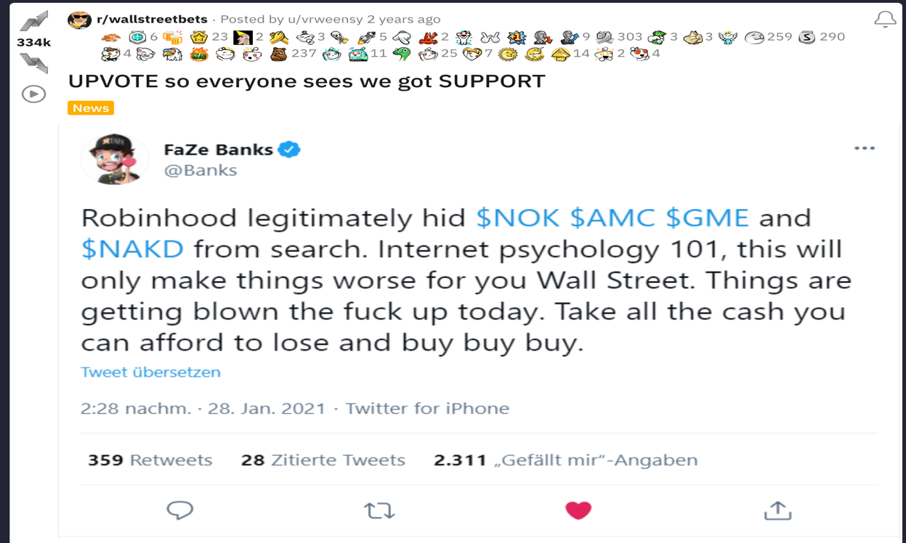
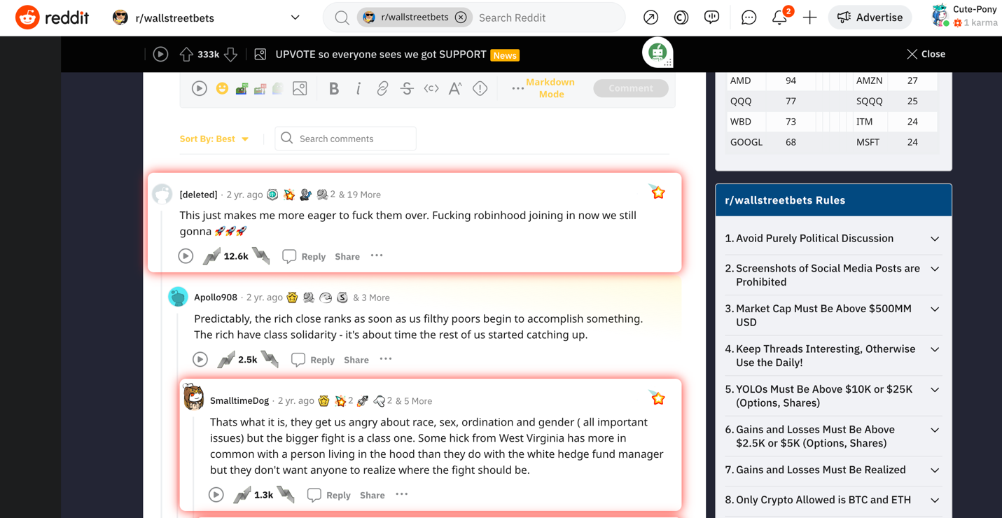


  - Preference on Trading Strategy

The other theme in the data I collected is positive. Short-selling is the practice of investors selling borrowed shares with the intention of repurchasing them at a cheaper price in the future to cover their positions. Short-selling is a prevalent activity due to the financial prospects it offers (Bettalio et al.). Short squeeze is exactly the opposite of short selling's strategy. When I coded "positive," it became evident that the content was supportive and optimistic about what would happen to, for example, the GME stock two years ago. This stock is also the most frequently mentioned ticker symbol in the top posts. People were advocating for others to purchase GME stock in order to make money after a certain period, and then sell them. At the same time, since they knew many hedge funds were betting the stock price would go down after a while, they bought a lot of low-priced GME stocks. People on this subreddit were trying to encourage others to hold, rather than sell, the stocks in the comments. The theme that appears more frequently in these interactions is people expressing support and positivity, rather than discouragement or negativity. They cheer each other up with emojis of rockets, hands, and diamonds, and they also express more positive energy than negative responses. In the table below, we can see that the number of green colors outweighs the red colors. I marked positive/optimistic responses as green and negative/hateful comments as red (the same as bull and bear indicator colors). They are more willing to encourage people to hold and buy more GME stock, rather than sell at an early point.
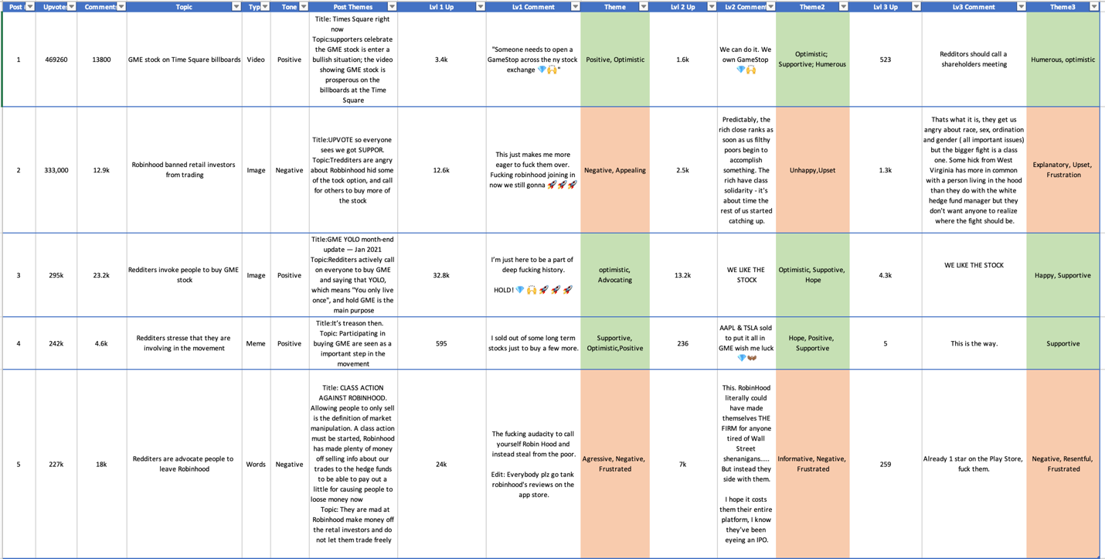

  - Online Socialization Behavior

I am interested in investigating which types of media people prefer to actively respond to, among different categories such as images, videos, memes, and text. To do so, I have collected data on the number of upvotes in each category and tracked the frequency of each category using a bar chart. This approach allows me to analyze the categorical data concisely and effectively convey the information in an easy-to-understand way.
I have labeled memes, general pictures, videos, and text as categories one, two, three, and four, respectively. Based on the data collected, the category with the most responses is memes (category one). This suggests that more people are responding to memes, resulting in a greater number of upvotes. On the other hand, text responses have the least frequency of response, which is indicated in category four. More information on the data collection process is provided in the codebook. So far, the community is evenly divided in their comments, with a split between different types of posts.

Conclusion

In conclusion, there are limitations to the data used in this study. Firstly, there is a limited amount of documented research available, and some of the research used was too old to be considered representative. Additionally, while comments on Reddit come from users all over the world, it is not a fully representative sample since the majority of users are white males from western countries, leading to selection bias in the data collection process. While the data may provide some insight into the subject, it may also lead to biased results. Moreover, selection bias is produced from this study as it only examines data from the social media platform Reddit, and there could exist other discussions on Discord, Facebook, or Instagram. Another perspective is that people may have a passive response mechanism, where they simply upvote to follow the social norm without fully engaging with the content. Given the rapidly evolving financial world and the impact of AI technology, future research could focus on continuously changing trading strategies discussed on other social media platforms or in addition to Reddit to collect a larger sample size. Moreover, researchers could investigate how socialization on social media could positively impact people in other real-life contexts.

References
Battalio, R. H., Mehran, H., & Schultz, P. H. (2012). Market declines: What is accomplished by banning short-selling? SSRN Electronic Journal. https://doi.org/10.2139/ssrn.2128827
Diether, K. B., Lee, K.-H., & Werner, I. M. (2008, May 9). Short-sale strategies and return predictability. OUP Academic. Retrieved March 10, 2023, from https://academic.oup.com/rfs/article-abstract/22/2/575/1596032
Foxman, S., Verhage, J., & Woolley, S. (2018, October 15). Robinhood gets almost half its revenue in controversial bargain with high-speed traders. Retrieved March 21, 2023, from https://www.bloomberg.com/news/articles/2018-10-15/robinhood-gets-almost-half-its-revenue-in-controversial-bargain-with-high-speed-traders#xj4y7vzkg
Lamont, O. (2004, July 26). Go down fighting: Short sellers vs. firms. Retrieved March 21, 2023, from https://www.nber.org/papers/w10659
Kurani, A., Doshi, P., Vakharia, A. et al. A Comprehensive Comparative Study of Artificial Neural Network (ANN) and Support Vector Machines (SVM) on Stock Forecasting. Ann. Data. Sci. 10, 183–208 (2023). https://doi.org/10.1007/s40745-021-00344-x

Pan, J., Zhuang, Y., Fong, S. (2016). The Impact of Data Normalization on Stock Market Prediction: Using SVM and Technical Indicators. In: Berry, M., Hj. Mohamed, A., Yap, B. (eds) Soft Computing in Data Science. SCDS 2016. Communications in Computer and Information Science, vol 652. Springer, Singapore. https://doi.org/10.1007/978-981-10-2777-2_7

Wen, Q., Chen, A. S., Bao, D., Cao, L. J., & Grudnitski, G. (2009, June 8). Automatic Stock Decision Support System based on box theory and SVM algorithm. Expert Systems with Applications. Retrieved February 3, 2023, from https://www.sciencedirect.com/science/article/pii/S0957417409005107?casa_token=OCWsq3NWI8sAAAAA%3AlmbEGR0mu6JyPd4oFw21DK23KPEqjN_bKgS6YjrnWR0HE2y_3vusBJ8-2_5WnzPK8lgRiArXNw

Codebook

Code | Meaning
Lvl 1 Up | Level 1 comment( first level of response) upvotes
1 | Image Post Meme
2 | Image Post General
3 | Video Post
4 | Text Post
Upvote | community support in reddit
Downvote | community negative opinion in reddit

